

Individual Final Report

|  |  |  |  |  |
| --- | --- | --- | --- | --- |
| Date: | 3 May 2020 | Student: | Chu Chi Hang | () |
| Supervisor: | Dr. T.W. Chim | Groupmates: | Ma King Wai  Lau Ngai Fung | ()  () |

|  |
| --- |
| **An Intelligent Assistant**  **for HKU Students** |

FINAL YEAR PROEJCT

Year 2019 – 2020

**THE UNIVERSITY OF HONG KONG**

**FACULTY OF ENGINEERING**

**DEPARTMENT OF COMPUTER SCIENCE**

# Abstract

Students in HKU access multiple websites, such as Portal for student account query and Moodle for learning resource. Some of these websites also not designed for mobile application, which occupied long loading time. A lot of time has spent on loading images in webpages and clicking buttons as springboards to retrieve a single piece of information like deadline of an assignment. Therefore, my project provides an intuitive solution for solving the problem: a personalized intelligent assistant in form of web application for HKU students to retrieve information from Moodle and Portal agilely and conveniently by giving voice or text commands to the Assistant directly, while at the server web scraping technique are used to capture the user needs and pack it as a response. Along the project, the web scraping part consists of highly specialized function, which imposes great effort in maintenance and development. To make it extendible to other websites and functionalities, building an organized and flexible structure is the heart of the project. Apart from that, fast scraping and parsing is crucial to the overall performance, and a set of tools and techniques are utilized. This report focuses on web scraping and explore the general solution of parsing data without direct accessing database and adoptive to visual layout.

# Acknowledgement

I would like to thank our supervisor, Dr. T.W. Chim, whose expertise was invaluable in guiding me to direction of developing new functionalities of my Final Year Project. I would also thank Eric Ma King Wai and Benjamin Lau Ngui Fung for providing a great deal of assistance and support along the project.

# Abbreviations

* HTTP

Hyper Text Transfer Protocol

* OO

Object Oriented

* HTML

Hyper Text Markup Language

* CSS

Cascading Style Script

* Web driver

A program which controls a browser to execute commands

# List of Figures

Figure 1‑1 HKU Portal display in desktop 10

Figure 1‑2 HKU Portal display in mobile device 10

Figure 1‑3 Steps to get assignment score 11

Figure 3‑1 PyCharm Community Edition Preview 15

Figure 3‑2 GitHub Desktop Preview 16

Figure 3‑3 PEP8 Coding Style Naming Convention 16

Figure 3‑4 Layering of web scraping module 18

Figure 3‑5 Class Diagram of web scraping module 19

Figure 3‑6 Inspecting HTTP request headers 22

Figure 4‑2 Initial design of NoteMaster 34

# List of Tables

Table 3‑1 Libraries used in web scraping module 21

Table 3‑2 Test result of Selenium Requests Integration Test 23

Table 3‑3 Test result of Browser Speed Test 24

Table 3‑4 Test result of web scraping approaches 24

Table 4‑1 ScrapeError types 25

Table 4‑2 CallError types 25

Table 4‑3 webutil functions 25

Table 4‑4 Testsuit development 27

Table 4‑5 testsuit3 functions 27

Table 4‑6 Browser attribute 28

Table 4‑7 Browser functions 28

Table 4‑8 global function in NativeBrowser.py 28

Table 4‑9 WebSite attributes 29

Table 4‑10 WebSite functions 29

Table 4‑11 Moodle attribute 29

Table 4‑12 Moodle functions 30

Table 4‑13 Portal functions 31

Table 4‑14 Global functions in HKUSites.py 31

Table 4‑15 WebMaster attributes 32

Table 4‑16 WebMaster functions 32

Table 4‑17 WebMaster settings 33

Table 4‑18 HKUNotifier functions 35

Table 5‑1 New functions in Branch 8 39

# List of Codes

Code 3‑1 Test program for Selenium and Requests (I) 22

Code 3‑2 Test program for Selenium and Requests (II) 23

Code 4‑1 Example use case of testsuit3 27

Code 4‑2 Create WebMaster with additional options 33

Code 4‑3 WebMaster use case 33

Code 4‑4 DialogFlow integration with web scraping module 36

Table of Content

Abstract 1

Acknowledgement 2

Abbreviations 3

List of Figures 4

List of Tables 5

List of Codes 6

1. Introduction 10

1.1. Background 10

1.2. Objective 13

2. Literature Review 14

2.1. Scraper 14

2.1.1. Requests 14

2.1.2. Scrapy 14

2.1.3. Selenium 14

2.2. Parser 14

2.2.1. Beautiful Soup 14

2.2.2. lxml 14

3. Methodology 15

3.1. Development Settings 15

3.1.1. Operating System 15

3.1.2. Library Documentation 15

3.1.3. IDE 15

3.1.4. Version Control 16

3.1.5. Code Style 16

3.2. Design 17

3.2.1. Requirements 17

3.2.2. Responsibility of Classes 18

3.2.3. Structure 19

3.3. Choosing library 21

3.3.1. Overview 21

3.3.2. Scraper Library 21

3.3.3. Parser Library 21

3.3.4. Others 21

3.4. Techniques 22

3.4.1. Integrate Selenium and Requests 22

3.4.2. Browser Speed Test 24

3.4.3. Scraping Speed Test 24

4. Result 25

4.1. Utility 25

4.1.1. weberror.py 25

4.1.2. webutil.py 25

4.1.3. testsuit.py 27

4.2. Scraper 28

4.2.1. NativeBrowser.py 28

4.2.2. HKUSites.py 29

4.2.3. WebMaster.py 32

4.3. Web Drivers 34

4.4. Notification 35

4.5. Integration with DialogueFlow 36

5. Conclusion 37

5.1. Deliverables 37

5.2. Future Work 38

5.2.1. Use Scrapy 38

5.2.2. Integrate Requests and Selenium 38

5.3. Deployment 39

5.3.1. Deploy Older Version 39

5.3.2. Integrate with Django Framework 39

5.3.3. Additional functions in Version 8 39

Appendix 40

A. Libraries 40

References 41

# Introduction

## Background

HKU provides more than one websites for student to access. Each of them has different use. For instance, HKU Portal manages students accounts, and HKU Library is focused on teaching resource. However, there are concerns on the usability of these websites.

The first concern is these websites are not designed for mobile devices. There are two distinct properties when mobile devices compare to others like desktop computer: (i) mobile devices has narrower monitors; and (ii) mobile devices has slower networking. For the (i), it is a common problem for mobile device users. According to the research of Alexndar Wenz [1], people took longer time to completing an online survey via mobile phone comparing to that of tablets. Besides, the research also mentioned that if the survey display is not optimized for mobile devices, the quality of survey response also degraded, indicating a poor control over devices. The display of HKU Portal is not designed for mobile devices. As reflected in Figure 1.2, the screen squeezes together without appropriate resizing, making the text unreadable and easy to wrongly clicked other buttons. This damages the user experience comparing to Figure 1.1’s display on desktop.

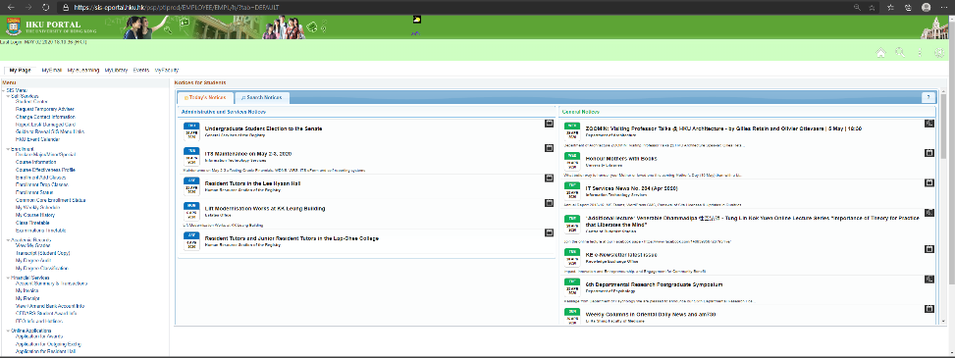

Figure 1‑1 HKU Portal display in desktop

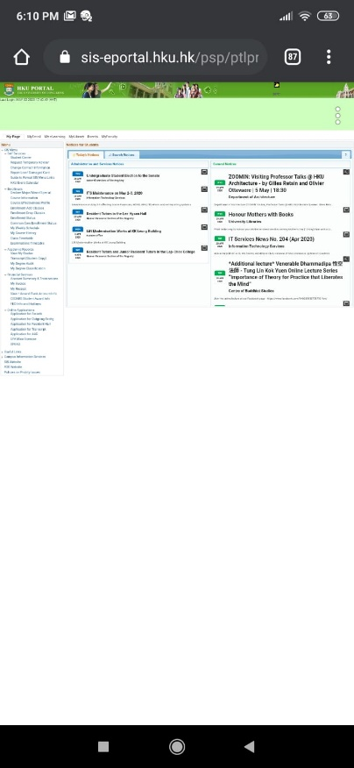

Figure 1‑2 HKU Portal display in mobile device

For (ii), the loading time is slower as mobile devices. As found by Brian’s research [2], mobile devices loads 87.84% longer than desktop. This may be due to the fact that mobile device uses wireless connections while desktop use wired connection. This results a significant difference when the website load background images or CSS style scripts, which further increases the loading time.

Apart from the mobile usage, multiple websites in HKU also make students difficult to manage. Sometimes student need to search across different sites to extract a piece of information when they do not know which website they should work on. It is still a problem even if one knows how to navigate the website. Illustrated by Figure 1.3, a student takes four click to access the assignment information, which means the browser need to load four pages. Besides, it consumes user’s time for searching the right link and reading other unnecessary information.

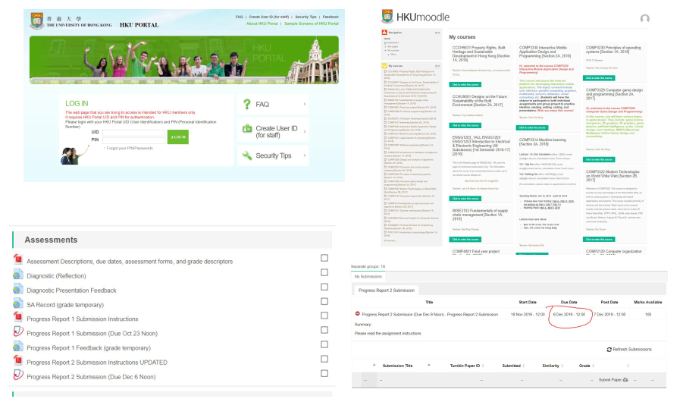

❷

❹

❷

❶

❶Login ❷Search course ❸Search content ❹View Result

Figure 1‑3 Steps to get assignment score

Therefore, to solve the above problem, a chatbot equipped with web scraping techniques is introduced for better user experience. Through using chatbot, it can simplify the long procedures and tedious management for websites. From the summary of Gil [3], about 70% of customers satisfy with a AI assistant (or chatbot) in general. More than 60% of the consumers use conventional assistant for buying products and services. This clearly shows that the use of chatbot might improve the quality of HKU websites. For more concrete reasons, chatbot can eliminate the need of loading background images and shorten searching time, which means visiting less pages and no need to search target manually, thus contributes to a faster loading time.

Furthermore, the entire chatbot application is independent of the website. There is no need to changes the UI as the display would not be visible to the user. This saves cost for redesign and manage visuals. Another benefit is that the page loading runs in backend server with wired connection, which is much faster than wireless access. Lastly, Adopting the system would not incur any changes to the existing websites. As the main data extraction is web scraping, no modification is required on database or page route logics.

## Objective

* Centralized Query

The Assistant provides a unified platform for accessing the information in HKU Portal and HKU Moodle without direct access. Such convenient is achieved by remote controlling a backend server equipped with stable network environment.

* Fast Loading

The Assistant can eliminate the time for accessing the website by two methods: (i) no need to load the assets in webpage such as background images, styling and unnecessary content, and (ii) compress the response of the Assistant by only providing text or image content, thus favorable to mobile devices.

* Precise Response

The answer replied by the assistant should not be vague or general. Instead of returning a wide range of correct solution, the assistant should return only the necessary information. For instance, returning the last assignment of Algorithm Course instead of returning a list of assignment in that course.

# Literature Review

## Scraper

### Requests

Requests is a simple, clean Python library for accessing websites. One major drawback is that it only can handle static HTML webpage. However, it has a lightning speed and easy to use.

### Scrapy

Scrapy is a framework for web scraping. It provides a set of tools which user only need to extend from the spider templates.

### Selenium

Selenium is a library designed for automate test for Web Applications. In another words, it simulates a human user controlling a browser by executing pre-written commands. Although it is a bit slow, it works with different browsers and handles dynamic JavaScript.

## Parser

### Beautiful Soup

Beautiful Soup is a famous library for parsing HTML. It enables flexible query with different HTML properties such as role and aria label. However, it requires external library for parsing.

### lxml

lxml is famous for speedy parsing. Not only HTML, it also can parses XML and support Xpath searching. However, it is less suitable for pure HTML parsing, especially for searching HTML element properties and displaying HTML code.

# Methodology

## Development Settings

### Operating System

Windows 10 is the OS for development.

### Library Documentation

In this project, Read the Docs (<https://docs.readthedocs.io/en/stable/>) serves as the standard documentation for each library. Based on its auto-update features, we believe it provides a much better display comparing to the GitHub open-source ReadMe file.

In case there is no available documentation in Read the Docs, we refer to the GitHub ReadMe file as the official documentation.

### IDE

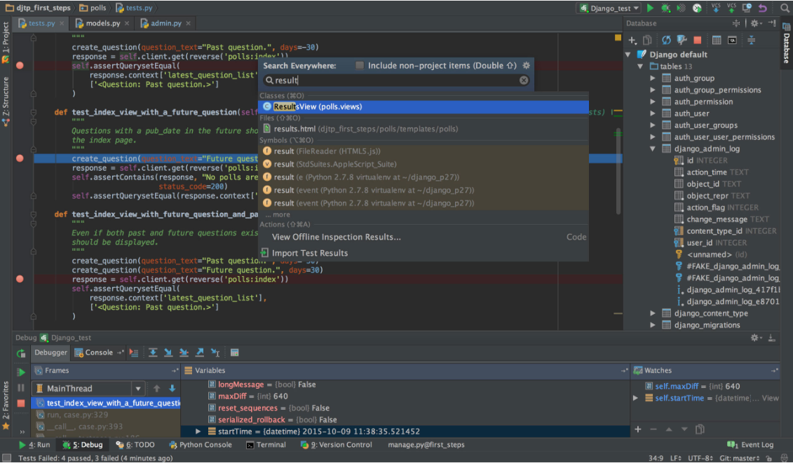

Figure 3‑1 PyCharm Community Edition Preview

I use PyCharm Community Edition (<https://www.jetbrains.com/pycharm/>) as the IDE of development. It provides high level of programming-favored features like refactor, code style checking and quick search, given its auto-coding support.

### Version Control

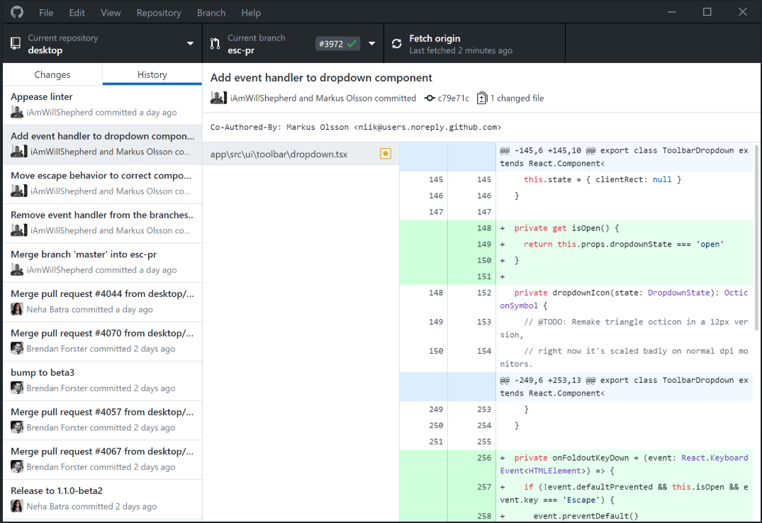

Figure 3‑2 GitHub Desktop Preview

GitHub Desktop (<https://desktop.github.com/>) is the major version control tools. As fully integrated with Windows 10 environment, it provides a simple and user-friendly control for Git operations.

### Code Style

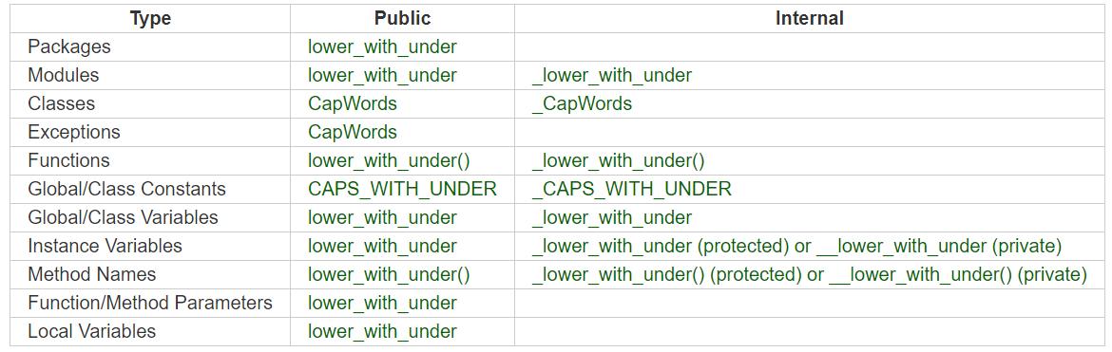

Figure 3‑3 PEP8 Coding Style Naming Convention

Following the PyCon 2016 guidelines on writing Python, PEP8 is adopted in this project. However, below are some places which fail to follow PEP8.

* Some lines are too long
* Module naming
* try-catch

## Design

### Requirements

There are a bunch of requirements the web scraping module would have to take care of. Below is a detailed list categorized by different aspects:

* Technical Requirement
  + Fast parsing and web scraping
  + Refresh webpage to prevent timeout
  + Manage browser tabs
  + Cache web scraping result
  + Check if webpage is updated
  + Record user function calls
  + Import only a single file for using web scraping module
* Structural Requirement
  + Introduce minimal changes when making changes
  + Able to work on different browsers
  + Error handling
  + Avoid duplications
* Development Requirement
  + Logging tools
  + Enable unit tests

Although the above list does not involve any use cases, it is the foundation before adding too many specific functions on scraping a particular target. To handle the above requirements, some strategies are devised to cope with:

* Create a Façade for end-user, which solve structure requirement
* Appropriate layering to separate responsibilities, thus enable robust testing
* Design templates before implementing concrete methods, thus allow pulling common methods and avoid duplications
* Indirect function calls to avoid rapid changes under development
* Extensive use of decorator pattern provided in Python to avoid duplications and enhance code readability

### Responsibility of Classes

As mentioned before, appropriate layering is necessary to handle the requirements. To visualize the design, Fig. 3.4 illustrates the separation and responsibility of each layers.

|  |
| --- |
| 5  Refresh  WebMaster  WebSite  Browser  User  Request  Manage Tabs  Record  Parser  Caching  Manage Website  Wait  JavaScript Action |

Figure 3‑4 Layering of web scraping module

From the above figure, there are three layers (classes) are covers the major requirements in Section 3.2.1. In particular, below is the additional role of each class:

* WebMaster servers as the façade for user
* WebSite and Browser are templates, and open to extend
* Browser is the wrapper version of Selenium Webdriver. It provides a set of commonly used methods, such as press key, waiting and switch tab.
* Since each is a different class, programmer can test Browser, WebSite and WebMaster separately.

However, the above architecture cannot separate scraper logic and parser logic. In development version, there was a design that indent to solve this problem. A WebManager class serves as a delegate between WebSite and WebMaster, which is responsible for parser logic. But in finalization (Version 7), it was removed as the implementation of WebManager is highly dependent on WebSites, and it would be better to put parser logic with scraper logic. As a compromise, detailed documentation and comments are written to ‘hold’ the structure.

### Structure

To realize the layered structure in Section 3.2.2, Object Oriented Design is adopted to make rather than directly building a layered structure. Figure 3.5 shows the OO design:

|  |
| --- |
| WebMaster  *Browser*  NewEdge  NewFirefox  *WebSite*  Moodle  Portal  0…*  NewChrome |

Figure 3‑5 Class Diagram of web scraping module

**WebMaster**

WebMaster contains and manage all the components (WebSite and Browser). It periodically refreshes the website, capture all the user function call and handle web scraping exceptions. Moodle and Portal are classes extended from Website template, which has its individual implementation of different web scraping methods. NewEdge, NewChrome and NewFirefox are concrete implementation of Browser interface.

In order to refresh, WebMaster extends from Python Standard Library Threading.Timer, which is a thread designed for waiting functions to carry out. By overriding the run method and constructor, webmaster can refresh itself periodically. Before destructing WebMaster, one must call the cancel method to terminate it properly by setting its finish flag to True.

Since there might be chances that conflict occurs when the WebMaster is refreshing the webpages and the user also requests for information, a mutex lock is set to the browser before any method intends to use the browser.

Before the WebMaster terminates, it will logout from all websites and quit the browser, thus not leaving any unterminated thread or program.

**WebSite**

Website is responsible for controlling low-level scraping and parsing logics. Its main duty includes:

* Login
* Logout
* Refresh
* Get sitemap

Apart from the above functions, it also stores a set of website links, e.g. login URL.

**Browser**

Browser is a wrapper of Web Driver. It mainly provides a better interface for calling function and import less libraries when using it. The function design of Browser is inspired by the jQuery API design. One of the noticeable idea is that the function can interpret the right meaning by inspecting the arguments, thus no need to split into other functions. More details will be revealed in Section 4.2.1.

## Choosing library

### Overview

Below is the list of libraries used in the project:

|  |  |  |
| --- | --- | --- |
| **Library** | **Usage** | **Installation** |
| Selenium | Get Webpage | ✓ |
| Beautiful Soup | Parser | ✓ |
| lxml | Parser | ✓ |
| cachetools | Caching | ✓ |
| inspect | Debugging | ✗ |
| traceback | Debugging | ✗ |
| time | Timing | ✗ |
| datetime | Timing | ✗ |
| re | Regular expression | ✗ |

Table 3‑1 Libraries used in web scraping module

### Scraper Library

Given that Requests cannot handle dynamic HTML, it cannot be the main scraper library. In later part of the report, trials are introduced to integrate Selenium and Requests.

According to the comment of Michael Yin (<https://www.accordbox.com/blog/web-scraping-framework-review-scrapy-vs-selenium/>), Scrapy is suitable for fast, large scale and huge data-driven project, while Selenium works well with JavaScript and small scale websites. Given the size of my project (2 websites) and JavaScript-intensive tasks, Selenium is the best choice in this project.

### Parser Library

Both Beautiful Soup and lxml are used in this project.

### Others

Selenium-Requests and Requestium are both libraries targeted on integrating Selenium and Requests. However, **the former is not working in browsers other than Firefox, and the latter is only designed for Google Chrome.**

**In order to speed up the web scraper and define hash keys, cachetools is included for faster and better performance.**

## Techniques

### Integrate Selenium and Requests

In order to speed up the web scraping process, I have tried to combine Selenium web driver and requests program. As requests cannot run JavaScript, it cannot perform redirect and click button when login HKU Portal. Therefore, one idea is to copy all the session and cookies from the Selenium web driver to requests.

|  |
| --- |
| from myutil.testsuit import testsuit3 as testsuit  @testsuit.log('test', 6, 'destroy webmaster') @testsuit.compileTest def test_destroy_webmaster(webmaster):  del webmaster  testsuit.printlog('field', 'Web Master')  testsuit.printlog('test', 0, 'create webmaster')  test_result = {}  test_result['needBrowser'] = test_destroy_webmaster(webmaster) |

Code 3‑1 Test program for Selenium and Requests (I)

Although it is workable for some trials, over 40% of the trials are invalid. Therefore, another idea is raised: supply all browser argument inside the request header, such as browser type, status code and referrer policy.

To do this, I inspected the requests by login manually and check the request headers. Programmatically, I copy the browser headers by checking the Selenium web driver and supply hard coded arguments if not provided.

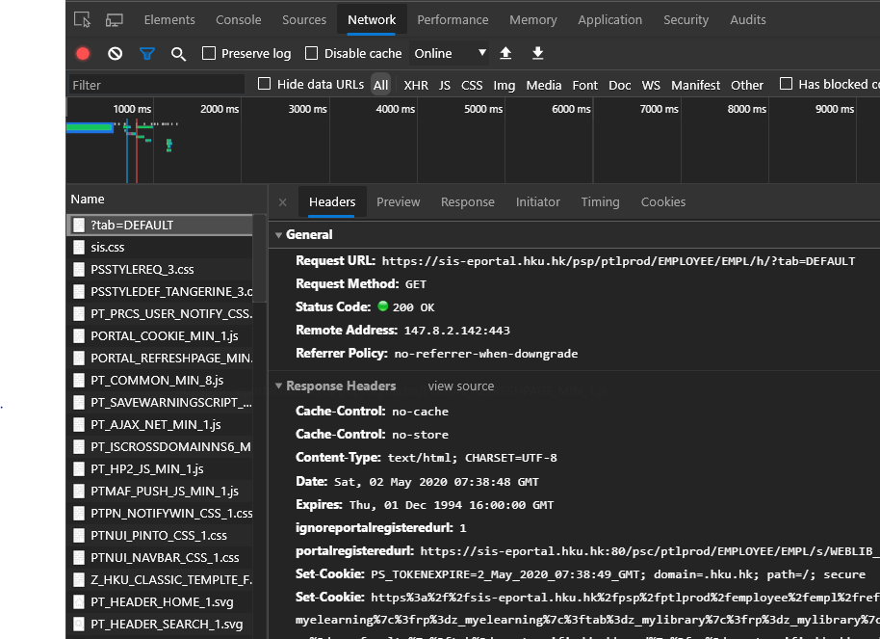

Figure 3‑6 Inspecting HTTP request headers

|  |
| --- |
| from myutil.testsuit import testsuit3 as testsuit  @testsuit.log('test', 6, 'destroy webmaster') @testsuit.compileTest def test_destroy_webmaster(webmaster):  del webmaster  testsuit.printlog('field', 'Web Master')  testsuit.printlog('test', 0, 'create webmaster')  test_result = {}  test_result['needBrowser'] = test_destroy_webmaster(webmaster) |

Code 3‑2 Test program for Selenium and Requests (II)

However, even supplying additional header arguments does not help to solve the problem. From Table 3.2, 40% of the trials still failed. As this is too unstable, requests is removed from the whole development.

|  |  |  |  |
| --- | --- | --- | --- |
| Browser | Chrome | Edge | Firefox |
| Version | 81.0.4044.129 | 81.0.416.64 | 75.0 |
| Headless | ✓ | ✗ | ✓ |
| Trial 1 | 398.989315986633 | 240.539052486420 | 198.991411209106 |
| Trial 2 | 384.157512187958 | 243.031306028366 | 201.003832817078 |
| Trial 3 | 383.444612503052 | 238.081277847290 | 205.299703359604 |
| Avg. | 388.864 | 240.551 | 201.765 |

Table 3‑2 Test result of Selenium Requests Integration Test

|  |
| --- |
| File, folder icon  testRequests.py |

### Browser Speed Test

|  |
| --- |
| File, folder icon  testBrowser.py |

**In order to provide the best web scraping speed, the choice of browser is critical. Therefore, I have conducted the same tasks for the three major browsers: Google Chrome, Chromium-based Edge and Firefox Quantum and repeat for 10 times. Below is the test result:**

|  |  |  |  |
| --- | --- | --- | --- |
| Browser | Chrome | Edge | Firefox |
| Version | 81.0.4044.129 | 81.0.416.64 | 75.0 |
| Headless | ✓ | ✗ | ✓ |
| Trial 1 | 398.989315986633 | 240.539052486420 | 198.991411209106 |
| Trial 2 | 384.157512187958 | 243.031306028366 | 201.003832817078 |
| Trial 3 | 383.444612503052 | 238.081277847290 | 205.299703359604 |
| Avg. | 388.864 | 240.551 | 201.765 |

Table 3‑3 Test result of Browser Speed Test

**As a final result, Firefox has the shortest loading time.**

### Scraping Speed Test

|  |
| --- |
| File, folder icon  testScrapeskill.py |

**There are two methods to parse a HTML segment: first select by selenium browser, and then parse as little as possible; or parse the whole HTML page, and select element as accurate as possible. To distinguish which approach is faster, a test is conducted by scraping an element repeatedly for 10 times. Below is the test result:**

|  |  |  |
| --- | --- | --- |
| Approach | Parse All First | Select First |
| Trial 1 | 9.618555545807 | 9.277193546295 |
| Trial 2 | 10.124194860458 | 9.442327976227 |
| Trial 3 | 11.125134468079 | 9.645575761795 |
| Avg. | 10.289 | 9.455 |

Table 3‑4 Test result of web scraping approaches

**Note: Firefox is the browser in this experiment.**

# Result

## Utility

|  |
| --- |
| File, folder icon  myutil/*.py |

### weberror.py

weberror defines the possible exceptions that might be thrown in the process.

|  |  |
| --- | --- |
| Type | Message |
| 0 | Scrape Error: Element Not Exist |
| 1 | Scrape Error: Page Not Exist |
| 2 | Scrape Error: Invalid Result |
| Any | Scrape Error: Others |

Table 4‑1 ScrapeError types

|  |  |
| --- | --- |
| Type | Message |
| 0 | Call Error: Function Not Exist |
| 1 | Call Error: Require Argument |
| 2 | Call Error: Ambiguous Function Call |
| 3 | Call Error: Invalid Argument |
| 4 | Call Error: Missing Argument |
| Any | Call Error: Others |

Table 4‑2 CallError types

### webutil.py

A list of functions that is useful in the project.

|  |  |  |  |
| --- | --- | --- | --- |
| Function name | Input | Output | Usage |
| util_universal_hku_login | browser, credential | None | Login |
| util_soup2list | beautiful soup object | HTML text with tr and td transferred to 2d rows | Parse HTML tables |
| util_list_search | search_list, quota, exact | List | Filter a list according to quota and exact |

Table 4‑3 webutil functions

### testsuit.py

For better testing, testsuit.py in myutil is created for this purpose. Currently there are three versions of testsuit:

|  |  |
| --- | --- |
| Version | Approach |
| 1 | Inherit the class to extend the test methods |
| 2 | Create a class which accept function as variables |
| 3 | Decorators and functions grouped in a dictionary |

Table 4‑4 Testsuit development

Only version 3 is discussed in details.

**Functions in testsuit3**

|  |  |  |  |
| --- | --- | --- | --- |
| Function name | Input | Output | Usage |
| compileTest* | None | Boolean | Ensure smooth |
| timedTest* | Repeat | Duration | Time the code |
| errorTest* | None | Boolean | Show error |
| log* | Formattype, tab, msg | None | Print debug log |
| printLog | Formattype, tab, msg | None | Print debug log |

* Decorator function

Table 4‑5 testsuit3 functions

|  |
| --- |
| from myutil.testsuit import testsuit3 as testsuit  @testsuit.log('test', 6, 'destroy webmaster') @testsuit.compileTest def test_destroy_webmaster(webmaster):  del webmaster  testsuit.printlog('field', 'Web Master')  testsuit.printlog('test', 0, 'create webmaster')  test_result = {}  test_result['destroy_browser'] = test_destroy_webmaster(webmaster) |

Code 4‑1 Example use case of testsuit3

Instead of returning the result of the code, the decorator functions modify the return of the function and give test related data.

## Scraper

|  |
| --- |
| File, folder icon  myscraper/*.py |

### NativeBrowser.py

**Browser**

|  |  |  |
| --- | --- | --- |
| Attribute name | Type | Usage |
| tabdict | Dict | Store the key-tab pairs for switching tabs |

Table 4‑6 Browser attribute

|  |  |  |  |
| --- | --- | --- | --- |
| Function name | Input | Output | Usage |
| constructor | Headless(boolean), options(list), path(str) | Browser instance | Create browser |
| press_key | key(str) | None | Press keyboard |
| wait | time(int) | None | Implicit wait |
| wait | time(int), ec(str), by(str), elem(str) | None | Explicit wait using Selenium functions |
| tab | target(str) | None | Switch to tab with key=target |
| tab | target(str), url(str) | None | Create tab with key=target and visit page with url=url |
| untab | target(set) | None | Delete tab with key=target |

Table 4‑7 Browser functions

**NewFirefox, NewEdge, NewChrome**

None

**Global**

|  |  |  |  |
| --- | --- | --- | --- |
| Function name | Input | Output | Usage |
| get_browser | browser(str), kwargs | Concrete Browser | Create concrete Browser specified by *browser* and *kwargs* |

Table 4‑8 global function in NativeBrowser.py

### HKUSites.py

**WebSite**

|  |  |  |
| --- | --- | --- |
| Attribute name | Type | Usage |
| sitemap | List | Sitemap of the website |
| site_links | Dict | Important URL of the website |
| site_name | Str | Name of the website |
| func_cache | Dict | Store the result of function call |
| html_cache | Dict | Store the length of HTML of URL |
| hash_func | Func | Hash function for caching |
| username | Str | Store login username |
| password | Str | Store login password |
| debug | Boolean | Print debug log |

Table 4‑9 WebSite attributes

|  |  |  |  |
| --- | --- | --- | --- |
| Function name | Input | Output | Usage |
| constructor | Username(Str), password(Str), cachesize(int), verbose(int) | Website instance | Create Website |
| print_debug | message(str) | None | Press keyboard |
| refresh | browser(int) | None | Refresh stale pages |
| destroy | browser(Browser) | None | Logout website and delete tab |
| start | browser(Browser) | None | Create tab, get sitemap and Login website |
| get_sitemap | browser(Browser) | None | Get sitemap |

Table 4‑10 WebSite functions

**Moodle**

|  |  |  |
| --- | --- | --- |
| Attribute name | Type | Usage |
| content_type | Dict | Store the content type of link pattern |

Table 4‑11 Moodle attribute

|  |  |  |  |
| --- | --- | --- | --- |
| Public Function | Input | Output | Usage |
| find_course_by_keywords | browser(Browser), keywords | (name, url) | Get the matching course name and link from sitemap |
| find_all_courses_by_keywords | browser(Browser), keywords | (name, url) | Get all the matching course names and links from sitemap |
| find_deadlines | browser(Browser) | List of dict | Get the deadlines of Moodle submissions |
| find_page_preview | browser(Browser), URL | Filename (str) | Get the screenshot of the URL page |
| find_course_contents | browser(Browser), keywords (string), type(list of string), search (2D list of string), quota (int), exact (Boolean) | List of dict / dict | Get the course contents by (i) keywords (search course), (ii) type of resource, search string (file name & section name), quota (position of contents), exact (return one or a list) |

Table 4‑12 Moodle functions

**Portal**

|  |  |  |  |
| --- | --- | --- | --- |
| Public Function | Input | Output | Usage |
| find_transcript | browser(Browser), keywords | Dict with lists | Extract transcript information |
| find_receipt | browser(Browser), url(str) | Dict with lists | Extract receipt information |
| find_account_activity | browser(Browser), url(str) | Dict with lists | Extract account activities |
| display_weekly_sch | browser(Browser), target_date(str), start_time(str),  end_time(str) | HTML string | Extract and modify schedule HTML |
| find_weekly_sch | browser(Browser), target_date(str), start_time(str),  end_time(str) | List of dicts | Extract schedule |

Table 4‑13 Portal functions

**Global functions**

|  |  |  |  |
| --- | --- | --- | --- |
| Function name | Input | Output | Usage |
| get_website | website(str), username(str), password(str), kwargs | Concrete Website instance | Create concrete WebSite specified by *website* and *kwargs* |
| switch_tab* | None | None | Switch to the tab of website page |
| browser_cached* | None | HTML | Check if the webpage is changed; if not, return cached output; else execute input function and caches it |

* Decorator function

Table 4‑14 Global functions in HKUSites.py

### WebMaster.py

**WebMaster**

|  |  |  |
| --- | --- | --- |
| Attribute name | Type | Usage |
| websites | Dict | Store website name - Concrete WebSite pairs |
| record | List | Record user function call |
| browser | Browser | Store Concrete Browser instance |
| mutex | Lock | Lock for using *browser* |
| username | Str | Login |
| password | Str | Login |
| debug | Boolean | Determine to print debug log |

Table 4‑15 WebMaster attributes

Some attributs in WebMaster are just for creating website or browser instance, which are not shown in the above table.

|  |  |  |  |
| --- | --- | --- | --- |
| Function name | Input | Output | Usage |
| constructor | username, password | Website | Create webaster instance |
| need_browser* | None | None | Infernal functions for acquiring lock for browser |
| refresh | None | None | Refresh websites in webmaster |
| cancel | None | None | Decstructor |
| create_website | website_name(str) | None | Create website instance with key=*website_name* |
| delete_website | website_name(str) | None | Remove website instance with key=*website_name* |
| format_record | website_name, func_name, args | Formatted String | Internal functions for format records |
| add_record | website_name, func_name, *args | None | Add record |
| get_record | None | List of records | Get the user function calls |
| print_debug | Message(str) | None | Print debug log |
| query | website_name, func_name, *args | Result of calling *func_name* | Call function as *function_name* of website |
| scrape | website_name, func_name, *args | Result query method | Wrapper for calling query method |

* Decorator function

Table 4‑16 WebMaster functions

**WebMaster settings**

As for the purpose of development, you can enable a bunch of settings for webmaster:

|  |  |  |  |
| --- | --- | --- | --- |
| Settings | Value Type | Options | Effect / Use |
| headless | Boolean | True | No browser display |
| False | Open Browser Display |
| browser | String | Edge | NewBrowser is Edge |
| Chrome | NewBrowser is Chrome |
| Firefox | NewBrowser is Firefox |
| verbose | Integer | 0 | No debug log |
| 1 | Print debug log of WebMaster |
| 2 | Print debug log of WebMaster and Website |
| cache | Integer |  | Cache size of Website |
| Init_setting | String | All | Login all websites at creation |
| Only Portal | Only login Portal at creation |
| On demand | Only login when needed |

Table 4‑17 WebMaster settings

The method to include the setting is exemplified as below:

|  |
| --- |
| from myscraper.webmaster import WebMaster  webmaster = WebMaster(credential['username'], credential['password'], verbose=2, browser_name='Firefox') |

Code 4‑2 Create WebMaster with additional options

**WebMaster use case**

|  |
| --- |
| from myscraper.webmaster import WebMaster  # create WebMaster webmaster = WebMaster('username', 'password')  # use WebMaster result = webmaster.query('Moodle', 'scrape_deadlines')  # get WebMaster history records = webmaster.get_record()  # not in use webmaster.cancel() |

Code 4‑3 WebMaster use case

## Web Drivers

|  |
| --- |
| File, folder icon  myengine/*.exe |

This folder stores the list of web drivers used in the web scraping module.

* chromedriver.exe: web driver for Google Chrome
* geckodriver.exe: web driver for Quantum Firefox
* MicrosoftWebDriver.exe: web driver for Microsoft Edge

## Notification

|  |
| --- |
| File, folder icon  notification/*.py |

Notification module is a module build on top of the web scraping module. The key idea of the notification module is to actively alert user important information. Therefore, it serves as the user of WebMaster, parse information and record the time to alert the notification. The idea of the notification module is similar to web scraping module which can be explained by Figure 4.2.

|  |
| --- |
| NoteMaster  0…*  *Notifier*  …  Notifier  Notifier  Notifier |

Figure 4‑2 Initial design of NoteMaster

In late development, the notifier class even disintegrated into functions only, as the notifiers only return a structured dictionary.

|  |  |  |  |
| --- | --- | --- | --- |
| Function name | Input | Output | Usage |
| portal_next_lesson_strategy | Webmaster  (WebMaster) | Dict | Alert if next lesson is near |
| portal_get_invoice_strategy | Alert if unpaid invoice |
| moodle_deadline_strategy | Alert if deadline is near |

Table 4‑18 HKUNotifier functions

For NoteMaster, it remains as a class extended from Threading.Timer, and acts as a registry to check whether the alerts are ready to signal to user.

## Integration with DialogueFlow

To integrate web scraping module with DialogueFlow, additional logics are included in views.py.

|  |
| --- |
| from myscraper.webmaster import WebMaster from .detect_intent_texts import detect_intent_texts   PROJECT_ID = 'hku-intelligent-assistant-bojt' LANGUAGE_CODE = 'en-US'  def chat_view(request):  session_id = request.session.session_key  query_text = request.POST.get('msg')  detect_intent_response_data = detect_intent_texts(PROJECT_ID, session_id, query_text, LANGUAGE_CODE) detect_intent_response_data["intent_display_name"] == "invoice-info-intent":  findInvoice = getWebMaster(request.session.session_key).query('Portal', 'findInvoice')  response_data['content'] = findInvoice  response_data['detected_intent'] = 'findInvoice' return JsonResponse(response_data) |

Code 4‑4 DialogFlow integration with web scraping module

The major function is to use detect_intent_texts to bind between the project and the application. It passes the user input to the model and receives the matched intent (detect_intent_response_data). After that, from the matched intent, supply the argument and call corresponding function of webmaster for scraping (discussed in Section 4.3).

# Conclusion

## Deliverables

All the files can be access in GitHub page:

<https://github.com/Vini3x3/HKU-Website-Scraping/>

|  |  |
| --- | --- |
| Version | Description |
| 0 | A set of scraper functions |
| 1 | Start using OOP concepts |
| 5 | Stable release before HKU Portal Upgrade,  Provided infrastructure for development,  Does not contain workable scraping functions. |
| 6 | Stable release before HKU Portal Upgrade,  Provided infrastructure for development,  Contain workable scraping functions. |
| 7 | Stable release before HKU Portal Upgrade  Eliminate development tools |
| 8 | Stable release after HKU Portal Upgrade |
| 9 | Stable release after HKU Portal Upgrade,  Rewritten with PEP-8 standard and redesigned |

Table 5.1 Versions in web scraping module

|  |  |
| --- | --- |
| Branch | Description |
| 8_1 | Additional extension for deployment  Add notification module |
| 8_2 | Finalized version for deployment |
| 9_1 | Add notification module  Additional extension for deployment  More structural upgrade |
| 9_2 | Finalized Version  Semantically use Python OOP |

Table 5.2 Branches in web scraping module

Branch X_Y means that the branch is fork of version X and locates at subversion Y. Due to the situation in deployment explained in Section 5.3.1, Branch 8_2 is used in the group project deliverables.

## Future Work

### Use Scrapy

Although Scrapy is not included in this project, it is interesting to test will Scrapy scrapes faster than raw code. Besides, using Scrapy will only changes the middle layer of the structure (WebSite) in Section 3.2.2, making the adaptation easier.

### Integrate Requests and Selenium

As mentioned in Section 3.4.1, the integration has failed. However, it is worthy to keep exploring the method of simulating browser requests by supplying the arguments in HTTP requests. In many cases, the web scraping does not need much JavaScript action, thus fast scraping static webpage can boost the overall speed.

## Deployment

### Deploy Older Version

Since Version 8 of the web scraping module appears earlier than Version 9, it has already integrated with the Django and DialogueFlow. Therefore, Version 8 is the main base for development and continues to add new functions upon request. Branch 8_1 and Branch 8_2 are created for this purposes.

Although Version 8 is operational, some of its code remain unfactored, such as the caching of scraping functions in HKUSites.py. In order to make it better, part of the code is refactored, such as exception handling and caching.

### Integrate with Django Framework

As mentioned in Section 4.4, NoteMaster refreshes itself periodically to check for alerts and send alert to front-end. To complete the request-response cycle rather than an abrupt backend signal to front-end, a thread is written in front-end to refresh every 10 minutes and check for any alerts. Therefore, NoteMaster does not need to extend from a Timer thread; it only need to passively wait for call. This simplifies the design logic and make less error by managing threads.

### Additional functions in Version 8

At the late stage of development, new scraping functions are built in Branch 8_1 and Branch 8_2 at HKUSites.py. The summary of these functions are listed as below:

|  |  |
| --- | --- |
| Function | Description |
| findTable | Find tables with table id in HKU Portal, reusing findInvoice, findReceipt, findAccountActivity |
| scrapeFolder | Scraper function which scrape folder page in HKU Moodle |
| findCourseContents | Scraper function which scrape course content with section name (e.g. add “lecture” label to file under section “lecture”) |
| listSearch | Handle dynamic list search, such as “second last item in list” |
| listMatch | Check if the target string matches any of the keywords in list |
| superSearch | Reusing listSearch, scrapeFolder and findCourseContents to combine a super search function |

Table 5‑1 New functions in Branch 8

# Appendix

## Libraries

Cachetools

<https://cachetools.readthedocs.io/en/stable/>

Selenium

<https://selenium-python.readthedocs.io/>

lxml

<https://lxml.readthedocs.io/en/latest/>

Beautiful Soup

<https://beautiful-soup-4.readthedocs.io/en/latest/>

Requests

<https://requests.readthedocs.io/en/master/>

Scrapy

<https://docs.scrapy.org/en/latest/>

Requestium

<https://github.com/tryolabs/requestium>

Selenium-Requests

<https://github.com/cryzed/Selenium-Requests>

PEP8

<https://pep8.readthedocs.io/en/release-1.7.x/>

# References

|  |  |
| --- | --- |
| [1] | A. Wenz, "Completing Web Surveys on Mobile Devices:," Institute for Social and Economic Research, 2017. |
| [2] | B. Dean, "WE ANALYZED 5.2 MILLION DESKTOP AND MOBILE PAGES Here’s What We Learned About Page Speed," backlinko, 2019. |
| [3] | G. Press, "AI Stats News: Chatbots Lead To 80% Sales Decline, Satisfied Customers And Fewer Employees," *Forbes,* 25 September 2019. |